YFHS 2024
Information for applicants – Please read before completing the application form
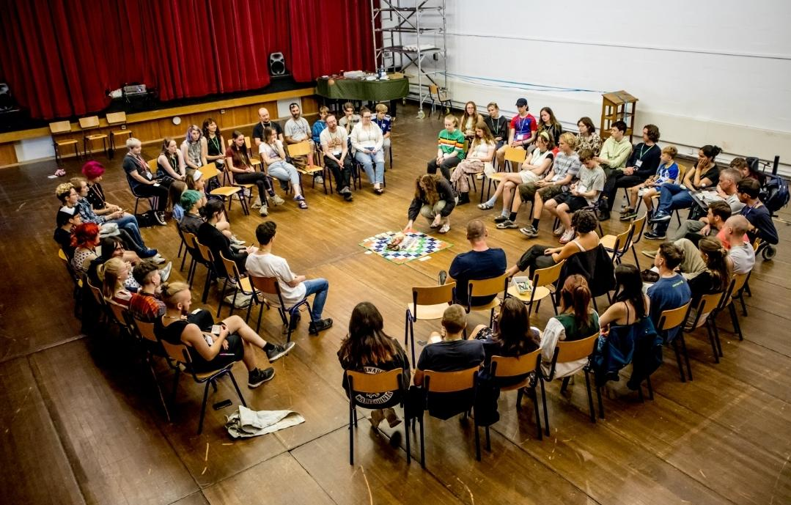
We are pleased to announce that Yorkshire Friends Holiday School will once again be held at Bootham School in York, from Sunday 18th to Sunday 25th August 2024.
Application Forms
Holiday School is open to all who are associated with a Local Meeting of the Society of Friends, either as Members or Attenders. Non-Quakers are also very welcome.
Applicants must be aged between 13 and 18 on 31st August 2024.
Application forms should be completed in full and submitted online via this link: https://forms.gle/W8RypQfr1uJ9dbx69 or at www.yfhs.org.uk. If you require a paper copy of the application form please contact yfhssecretary@gmail.com.

Fees

The cost this year will be £380 including a non-refundable deposit of £80. Final payments are due by Friday 21st June 2024

We prefer payments by electronic transfer. Payments from within the UK should be made to YFHS, Sort Code 56-00-70 Acct No 66002214. Please include the participant’s name in the payment reference so we can easily identify payments.

If making electronic payments from outside the UK, please ensure that the payment is exchanged into sterling before the transfer is made. This should avoid any fees being deducted from the payment. If any fees are deducted, we may request an additional payment of the balance. Our Bank Identifier Code (BIC) is NWBKGB2L and our International Bank Account Number is GB28NWBK56007066002214.

We can accept cheques if necessary, these must be made out in Pounds Sterling to YORKSHIRE FRIENDS HOLIDAY SCHOOL. All cheques should be posted to: Mark Robinson, 164 Cross Lane, Crookes, Sheffield, S10 1WP

We are sorry, but we cannot accept Euro-cheques. We can accept late applications after the final payment date but prefer to receive applications earlier if possible so we’ve a good idea of the expected number of participants.

Please note that we’re unable to reserve a place unless a deposit for £80 is paid with the application.
Residence

It is expected that all participants will be present for the whole week. Only under exceptional or unforeseen circumstances will young people be permitted to arrive late or to leave early.

Exam Results
If a participant will be collecting Exam Results during the week of YFHS we ask that you let us know in advance. We appreciate it is sometimes necessary for them to return to school to register for college etc. but ask that participants return to Holiday School as soon as possible.

Please contact us in advance as soon as you know what arrangements you are making for exam results.
Off-site visits

Bootham School is situated just ten minutes’ walk from the very centre of the beautiful city of York. We may allow free- time unsupervised visits where participants are organised into groups of three to five. The application form includes a request for parental permission, without which individuals will not be allowed to leave the site.

Holiday School Boundaries

We only have a handful of rules at Holiday School, but they are important. We expect applicants and their parents/guardians to have read them before completing the application form.

ALCOHOL - anyone found in possession of alcohol, or under its influence, will be asked to leave immediately.

DRUGS - anyone found in possession or under the influence of illegal substances will be asked to leave immediately. Further action may be taken as appropriate.

SMOKING - Bootham School has a single designated smoking area. We ask that smokers identify themselves to the staff at the beginning of the week, we ensure that the event isn’t a place where anyone takes up smoking.

INTRUSIONS INTO PERSONAL PRIVACY - including visits to bedrooms by members of the opposite sex, are forbidden at all times.

ANTISOCIAL BEHAVIOUR - we treat very seriously any behaviour that threatens to damage the caring and inclusive spirit of Holiday School.

The success of Holiday School depends on all applicants agreeing to respect and abide by these boundaries.
Bursaries
Bursary help is available for anyone who needs it. Please do not hesitate to ask.
Applicants should be eligible for bursary assistance from their Local Meeting of the Society of Friends, so in the first instance, please contact your Local Meeting to discuss available support.
If you are unable to obtain bursary support from your Local Meeting, we may be able help with fees.
If you wish to request support directly from YFHS, please contact us at yfhssecretary@gmail.com. To help us with administration, we request that you approach us before the payment deadline of 21st June 2024. We will not be able to make a decision on bursary payments until after this date as our bursary funds are limited so we may need to decide how to share them between applicants. We will do everything possible to meet requests for bursary support.
If you are new to us, you can find out more about us on our website www.yfhs.org.uk
For any other queries about Holiday School, please email yfhssecretary@gmail.com or call Mark Rymer on 07870 892429
Yorkshire Friends Holiday School (www.yfhs.org.uk)
Supported by Quakers in Yorkshire

